CSA1708-ARTIFICIAL INTELLIGENCE
LAB EXPERIMENTS
Program 8 : Python Program to Implement Depth-First Search (DFS)
Aim
To develop a Python program to implement the Depth-First Search (DFS) graph traversal algorithm using recursion to explore nodes along each branch before backtracking.
Algorithm
1. Represent the graph as an adjacency list using a Python dictionary.
2. Select an initial start vertex for the traversal.
3. Initialize a visited set or list to keep track of nodes already explored.
4. Define a recursive DFS function that takes the current vertex and the visited set:
5. a. Mark the current vertex as visited and append it to the traversal order.
6. b. For each adjacent neighbor of the current vertex in the graph:
7. i. If the neighbor has not been visited, recursively call the DFS function on that neighbor.
8. The recursive call naturally backtracks when a vertex has no unvisited neighbors.
9. Invoke the recursive function starting from the designated initial node.
10. Display the complete sequence of vertices visited in DFS traversal order.

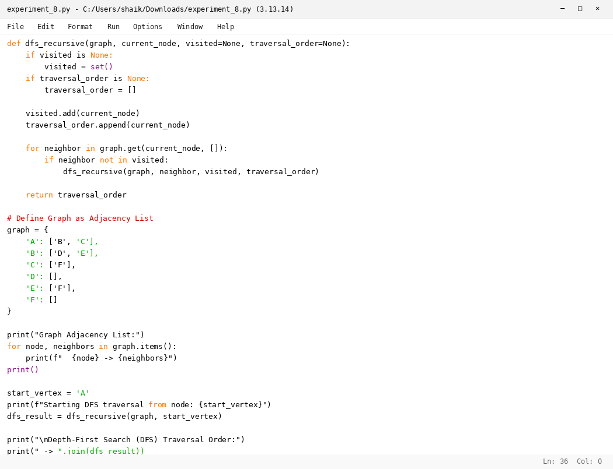

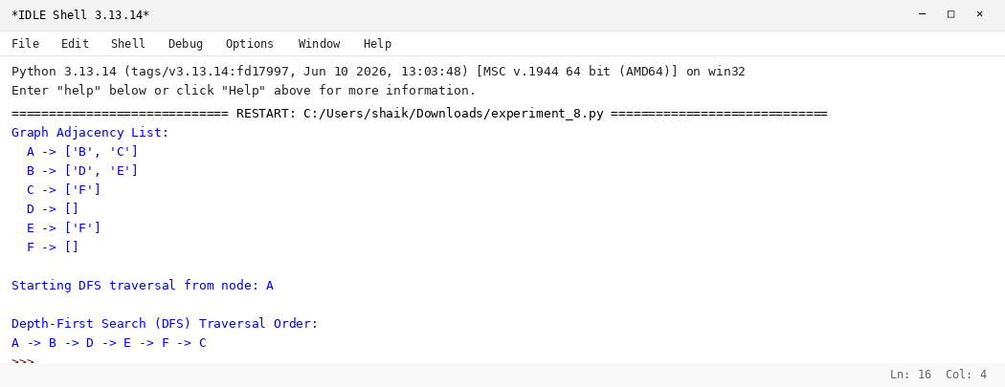

RESULT
Thus, the Depth-First Search (DFS) algorithm was implemented successfully using Python.

